Awareness Day at the Capitol

Preparing for Awareness Day
Master Planning Guide

Table of Contents

Introduction Page 3

Section A: Getting Started Page 4

Section B: Planning and Logistics Page 5 - 9

Section C: Awareness Day Page 9 - 10

Section D: Follow Up Page 11-12

Appendix Page 14 – 28

- OSBHA’s Staff Contact List Page 14

- Preparing for and Conducting a Meeting with Elected Officials Page 15-18

- Messages and Facts Page 19

- Create a Plan of Action to Tell Your Story Page 20

- Awareness Day Debrief Guidelines Page 21

- Directions to the State Capitol & Transportation Scholarships Page 23-24

- Legislator Thank You Letter (Sample) Page 25

- Share Your Story Form Page 26-27

- Checklist to Organize for Awareness Day Page 28

Introduction

SBHC Legislative Awareness Day at the Oregon State Capitol is an annual effort by the Oregon School-Based Health Alliance (OSBHA) to highlight the impact of school-based health services on student health and academic achievement. The event provides an opportunity for young people to visit the capitol, meet their legislators, and link their personal stories to the importance of school-based health centers (SBHCs) in communities around the state. We encourage all to join us in this effort!

This tool-kit was created to assist School-Based Health Center (SBHC) programs to prepare for the annual SBHC Legislative Awareness Day coordinated by the Oregon School-Based Health Alliance (www.osbha.org). Included are tips on how to prepare and organize supporters to travel to Salem, as well as ideas on planning activities around the event at your home site(s). This guide details the action steps necessary for SBHC programs from around the state to help plan their participation for SBHC Legislative Awareness Day in Salem.

Section A: Getting Started - THE EARLIER THE BETTER!
Generate the interest for participation: Begin EARLY in the fall, soon after school begins!
At the School

- Speak with your school principal (and the superintendent, if possible) to invite the school/district to participate. Remind them about the importance of financial support from the Oregon State legislators for SBHCs. Tell them the date of this year’s SBHC Legislative Awareness Day and ask which teacher(s)/staff might be appropriate to travel to Salem.

- Explain the agenda to the principal so that goals and activities of the day are clear. The students are going to Salem to tell their stories about the importance of SBHC services in their lives.

- If the principal approves, speak with the appropriate teachers or school staff (such as Leadership or Health teachers and Youth Council Advisors) about taking their students to Salem as an educational field trip. Also find out if another interested teacher would like to recruit a group of students to attend Awareness Day.

- Develop student permission forms and photo releases that can be distributed by the teachers. This is a school trip and all students must be covered with parental permission.

- Inform appropriate school staff to help your outreach. For example, Student Government, Parent Coordinators, student associations, honor societies, etc.

- Compile the contact information of all interested chaperones (i.e. teachers, parents, other adults). Collected information should include email, work telephone, fax, and cell phone numbers. The ratio of staff/adults to students should depend on the age/grade level of the students.

- Compile and email an information sheet to the teachers, including your name, best way to reach you, special dates, transportation plans, departure and return times, lunch and snack information, etc.

- Constant and timely communication is key when preparing for the trip; keep chaperones informed as plans develop.

- If the school administration is not interested in sending students and staff to Salem, explore possibilities of planning activities around SBHC awareness to be held at the school on that same day or week. An open house for your local SBHC is a great idea.

At the School-Based Health Center program

- Notify your SBHC program colleagues about the event date via phone or e-mail.

- Include news about Awareness Day and related events on each team/staff meeting agenda to educate and build support for awareness activity.

- Send the same information sheets and up-dates of plans to the SBHC staff when it is sent to the teachers. Encourage SBHC staff and teachers to be in touch with each other as preparations are made.

- Inform any group of students and/or parents that work within your SBHC clinics who may be able or interested in participating. For example, peer educators, parent groups/class participants, and/or group alumni.
Set a deadline

- Schedule a deadline for school and SBHC staff to confirm they will attend Awareness Day.

- Plan with the school administration to schedule a deadline for students to return their consent forms and photo releases. Schools are responsible for collecting the consent forms.
Section B: Planning and Logistics

Arrange for Transportation

- Confirm the number of interested attendees. Notify OSBHA of the expected size of your group and anticipated arrival time.

- OSBHA has limited funds for reimbursements. Schools may be asked to contribute to the cost of transportation. Ask if the school would be able to finance transportation through the school’s budget.

- Contact OSBHA if you are interested in applying for a Transportation Scholarship to help cover some of the costs of transportation.

- Confirm that the bus company is approved by the school district to be a transport carrier for students before reserving the bus(es). (Regardless of who pays for the bus, the company should be a school-approved carrier.)

- Obtain copy of insurance liability of the bus company for the school records.

Schedule legislative meetings
- Call the office of your local legislator to schedule an appointment about a month in advance. Once your appointment is scheduled, confirm your meeting times with OSBHA.

- Make appointments with your senators and representatives – the best time would be between 12:30pm and 2:30pm.

- Ask for a 15 minute meeting. Legislators enjoy meeting with their constituents! If the legislator is unavailable, ask for a meeting with a legislative aide.

- To find out who your legislators are and their contact information, please visit http://www.leg.state.or.us/findlegsltr/home.htm

- Please try to schedule your appointments AFTER 12:30 pm so you can take advantage of our interactive training. However, the goal is to meet with as many Legislators as possible, so schedule the appointments for any time they can meet with your group while you are in Salem. It may be necessary for a small group of your students to leave the Awareness Day meeting room to meet with a Legislator.

- Check to see if any other SBHC programs within your area share your legislators and discuss the possibility of visiting the Legislator together. If so, schedule the appointment accordingly.

- Let the Legislator’s scheduler know how many people will be coming and what school and legislative districts they represent. Take note of the Legislator’s scheduler and time/date you spoke with him/her. Keep record of all written and verbal communication with the Legislator’s office. Preferably, send a formal appointment request/confirmation letter via mail, fax or email.

- If the Legislator is available and it does not interfere with your appointment, invite the Legislator and his/her aides to attend the Awareness Day event.

- Make sure to get the name of the staff aide who scheduled the appointment.

- Call again to confirm the appointment a week before Awareness Day. Confirm all meeting times with OSBHA.

- If possible, send an appointment confirmation letter with materials about your SBHC program and OSBHA.

Recruit Adult Advocates

- Invite parents, school staff, and supporting community-based organization staff to participate as chaperones as well as advocates for the SBHC program.

- The ratio should be at least 1 adult to 10 students. At least half of the total number of the adults should be school staff (principals, teachers, guidance counselors, etc.) and/or SBHC staff. The younger the students are, the smaller the ratio should be.
Make sure Consent Forms/Photo Release is collected: BEGIN EARLY!
  - The consent forms for students must be drafted, distributed and secured by the school staff. The Oregon School-Based Alliance will not be responsible for distributing or collecting the permission slips.

  - The SBHC program should confirm that all consent forms and photo releases have been received at least one week in advance.

  - Make a duplicate copy of forms and bring with you to the event. OSBHA would like to have the photo release forms on file.

  - Notify your agency’s Risk Management Department of the trip and ask for instruction/guidelines for the trip.
Know the School Procedure for Trips
All May Not Apply to Your District
  - The principal must approve all school trips in advance.

  - A trip plan must be prepared and be retained by school. The plan must specify all applicable information, including persons in charge, participating classes of students, activities and location to be visited, names of all adults taking part, details of departure and return, method of transportation and carrier, and insurance coverage.

  - The principal must designate a licensed teacher, assistant principal, or other supervisor participating in the trip as the individual with overall responsibility for the trip.

  - No student will be allowed to participate in a school trip unless his or her parent, guardian or person in a parental relationship to the student has signed a consent form.

  - Again, there must be at least one (1) adult per ten (10) students. The adults must be either the parents of a student, school staff, SBHC staff, or otherwise designated by the school as the chaperone.

  - Regardless of the type of trip it is not permissible for students to meet at or be dismissed from a site other than the school unless the consent form specifically authorizes it. Confirm the consent form lists the bus pick up and drop off location.

  - Any vehicle utilized to transport students must comply with all federal, state, city, and Department of Education rules and regulations for the transport of students.

  - OSBHA will not be liable for issues arising from the transportation to or from the event.
Have a Consistent Message

  - Meet with teachers, students, and parents/ other adults who are participating in Awareness Day to review talking points.

  - Specific talking points will be provided from OSBHA for Awareness Day.

  - Plan activities surrounding SBHC Awareness: petitions, letter writing, poster/essay contest, etc.
Get Emergency Numbers
  - Get the emergency numbers of all the adults with the group.

  - Advise the teacher/ adult chaperones to collect the emergency numbers for all the participating students. These adults should be aware of, and prepared to follow, their school district’s emergency policy.
Plan for Lunch/Snacks
  - OSBHA provides a snack and a lunch for attendees free of charge.

  - OSBHA will provide a vegetarian option for lunch. If attendees have other nutrition needs, they should let us know in advance.

  - Though lunch is provided, it is suggested that attendees bring healthy snacks for the trip to and from the event.
Outreach to the Media
- Notify the Public Relations Department of your school district about the event and any related activities in your school.
- Alert local media about the Awareness Day event—contact OSBHA if you would like technical assistance regarding this important advocacy step.

Finalize All Details
- Confirm all Legislator meeting appointments. Confirm all meeting appointments with OSBHA.
- Assign Bus Captains and confirm their emergency contact information
- Distribute emergency number contact information sheet.
- Ensure all documentation (student consent forms, photo waivers, etc.) are secured by the school staff.
Section C: Awareness Day
Coordinate Bus Pick up/ Drop off location
- Designate the area where the group will meet.

- Have all attendees sign in on an attendance sheet. The attendance sheet should have two (sign in) columns, one for participants to sign in at the beginning of the day and one to sign out at the end of the trip.

  - Give each chaperone/adult an Awareness Day packet containing the agenda for the day, the location and times of OSBHA events, their assigned legislative visits, and emergency numbers, etc.

  - Exchange phone numbers with the bus drivers in case of delays.

- If necessary, students should show their student identification cards to be allowed on the bus.

- Make sure the bus drivers and the bus captain have directions for the trip to Salem. Do not assume the bus driver knows the route or the parking information.
Driving Directions to Salem
- For driving directions and map, see Appendix
Be ready for Security
- No one needs to clear security to enter OSBHA meeting room area. However, attendees should not to bring knives, matches, nail files, etc.
- It is also advisable for students not to bring expensive electronic devices or expensive jewelry, as their presence may create problems between students, items may be lost, or stolen

Registration
- Prior to the event, register all sites online: https://goo.gl/forms/7vcGk0GB4OSl3tU03

- As attendees arrive at the main meeting hall, students and adults will check in at the registration table and provide OSBHA with a copy of your photo release and a copy of their
complete, signed story form. Once registered attendees should pick up Alliance materials and move to the main meeting area with their group.

Student Involvement
- Students are invited to voice their opinion and experiences about SBHCs. The student experience opportunity at the annual Awareness Day has become very popular. Students are outstanding advocates for school-based health care and SBHC providers should encourage students to be prepared to share their story.

- To encourage students to participate, let them know they may bring prepared notes and/or have a friend/group stand with them for moral support—see website for Telling Your Story form.
Conduct Legislative Meetings
- When you visit the Legislators’ offices, be sure to introduce yourself and identify the SBHC program you represent. Ask for the person who scheduled the appointment to thank them personally.

- If the Legislator is not available, ask if you may speak with the legislative staff person who is responsible for health issues.

- Go over the main points about SBHCs and hand in the packet of SBHC information you have prepared.

- If it is a large group, designate one to five people to speak about specific SBHC issues and about why SBHCs are important to them. Be sure they have the details they need.

- Invite the Legislator and his/her staff to visit your SBHC—having pre-set open houses is a great way to encourage attendance.

- Sign the guest book and make a brief note on the right side of the page urging their support for SBHCs.

- Refer to the Tips sheet provided by OSBHA on speaking with legislators.

Section D: Follow Up
Debrief about Awareness Day
  - Review the day with students, school staff, parents/adults, and with fellow SBHC staff members. Debrief immediately afterwards while still in Salem, on the bus ride home, or as soon as possible afterwards.

  - Discuss the accomplishments, challenges and decide on the next action steps.
Write Thank You Letters

  - Send the Legislator(s) a thank you letter within a week of the visit. There will be a station at Awareness Day to write these immediately!

  - Address the thank you letter to the Legislator(s). Thank him/her and any aides (if you met with an aide) for their time. In your letter, make special note of the staff member with whom you met.

  - Close the letter with an invitation to visit your SBHC.
Host a Site Visit
  - Call to invite the Legislator to visit your clinic. Offer three possible dates for the visit.

  - Inform the school administration as soon as a date is selected for the visit and invite them to participate.

  - Inform Public Relations Department of your school district and local media.

  - Plan for the visit with the SBHC, students, and school staff.
Other Activities
  - Ask students to write about their experiences for the local newspaper and the school newspaper.

  - Make a collage of the pictures to post in the clinic.

  - If there was no local media reporter at the event, send your statement and photos to the media immediately after Awareness Day.

  - Send a thank you note and summary of Awareness Day to each teacher and SBHC staff who participated.

  - If appropriate, give certificates of appreciation to students who assisted in planning activities.

  - Send a school group photo and caption or short story, best done digitally, about the trip to Awareness Day to the local school district administration for its district newsletter and also to OSBHA for its website.

APPENDIX LIST

A. Oregon School-Based Health Alliance’s Contact List Page 14

B. Preparing for and Conducting a Meeting with Elected Officials Page 15 – 18

C. Messages and Facts Page 19

D. Create a Plan of Action to Tell Your Story Page 20-21

E. Awareness Day Debrief Guidelines Page 22

F. Directions to the State Capitol and Travel Reimbursement Page 23-24

G. Legislator Thank You Letter Sample Page 25

H. Share Your Story Form Page 25-26

I. Checklist to Organize for Awareness Day Page 27

Appendix A: Oregon School-Based Health Alliance’s Contact List

Please contact us with additional questions or comments. www.osbha.org

Laurie Huffman
Executive Director
laurie@osbha.org
(503) 719-4515

Maureen Hinman
Policy Director
maureen@osbha.org
(503) 719-4515

Megan Kovacs
Program Manager
megan@osbha.org
(503) 719-4515

APPENDIX B: How to Prepare for and Conduct a Meeting with Elected Officials about School-Based Health Care

1. Know a bit of history:
The Oregon Legislature has been tremendously supportive of SBHCs in recent years. In fact, while many programs have been cut, SBHCs are one of the few programs that have grown! One of the main things you will do at Awareness Day is to THANK your legislators for their support of SBHCs and to make sure that they know how important SBHCs are in your community.

2. Know WHY we are having Awareness Day
a. We are building AWARENESS of the existence and importance of SBHCs. b. We are THANKING legislators for their support.
c. We are building SUPPORT for SBHCs amongst people who have the power to expand or cut money for the program.
d. We are giving youth a chance to SHARE what they are doing in their community and to
LEARN from others.
e. We are giving people the opportunity to ADVOCATE for their health care.

3. Know your Legislator. What district does she/he represent? Are there significant children’s health problems there, such as high rates of asthma? Do kids have access to other primary care, or is the SBHC the only source of such care? Know his/her position on issues related to the ones you plan to discuss. Has he/she supported or opposed SBHC funding? If the Legislator has been good on any of our issues, always start out by thanking him/her for past support.

4. Develop a strategy for the meeting. If you are accompanied by others, decide who will speak, and on what issues. Don’t feel intimidated. You “hire” your Legislators with your vote and “pay” them with your taxes. They want to represent their constituents’ interests and need to hear from you.

Here are some ideas for talking points:
a. What problems do kids face when they don’t have access to health care?
b. What do you like best about your school based health center?
c. What data make the case for school based health centers?
d. What impact does your school based health center have (or will it have) on your school?
e. What makes school-based health care different?

5. Focus on what you want. For example, when urging his/her support for SBHC funding, ask him/her to write to the Assembly Speaker or Senate Majority Leader to request that funding for SBHCs be retained in the state budget.

6. Do your research; bring local data to support your position. Examples include: the number of uninsured kids served; cuts in clinic funding and impact; asthma cases treated; complications prevented; hospitalizations averted.

7. Give real case examples, without real names, of kids with complex problems who were served by the SBHC, to show the important and unique role your clinics play in the communities the Legislator represents.

8. Listen carefully. Politicians tend to speak generally. Try politely to draw out specific answers to your specific questions about SBHC funding and legislation. If you are confused by the answer, ask for further clarification.

9. Don’t be afraid to admit ignorance. If you don’t know the answer to a question, say you will find
out and report back later.

10. Thank them for the visit. Invite them to see your clinics in their district. (Be sure to follow up when you get back home with a specific date for them to visit the clinic.)

11. Send a thank you letter that summarizes your understanding of what the Legislator agreed to do. Let them know you are available to provide them with further information if needed. During the year, send relevant clippings or articles with a brief note to keep the issues on their radar screen.

12. Schedule an appointment AFTER 12:30 pm. Call your legislators and ask them for 15 minutes of their time on February 26th, anytime after 12:30. We will be training in the morning and out of respect for the youth who are preparing those training, we ask you not to schedule a morning meeting. 11:30 will begin our lunch. The main switchboard number is 1-800-332-2313. You can find your legislators at: https://www.oregonlegislature.gov/findyourlegislator/leg-districts.html

Make your appointments NOW

Now you are ready!

During the Meeting:
- Be polite! You are representing your community.
- Be confident—shake their hands and look them in the eye.
- Don’t be disappointed if you meet with staff: meeting with legislative staff is as important as meeting with a legislator. From a former congressional staffer:
“The staff are the ones who run the ground game for Congress. Work on helping them understand and learn. Because, if the staff knows you, when they have a question about a piece of legislation or amendment, they will be the one you call.”
- Be flexible: Legislators have extremely busy and unpredictable schedules, which mean you may not always have as much time as you thought you would. A 15-minute appointment could turn into a 5-minute session, so you need to know what your key points are and be able to condense your message on short notice. Practice ahead of time and be ready to summarize!

Suggested Meeting Guide:

- The main points you may want to emphasize (see Best Messages):

- SBHCs are a great place for kids to access health care and will see you regardless of your insurance status.
- SBHCs get students the care they need, when they need it, so they can get back to class and learn.
- SBHCs reduce absenteeism and tardiness
- SBHCs are important to you—their constituent!

- Make sure everyone has a role in the meeting. You might consider assigning the following “roles” for your group:

  - The Opener: This person will introduce the group (have the youth say who they are) and tell a little bit about your school and why you are there. Explain that today is School-Based Health Center Awareness Day and they are there with the Oregon School-Based Health Alliance.

  - The Data Guru: This person will present 2 or 3 data points (such as the number of students who visited your health center last year, the number uninsured children in your county, the percent of kids with asthma, etc) that make the case for SBHCs. If you did not bring data with you, look in the data resources found in your packet.

  - The Story Teller: This person will tell a brief story about how their SBHC helped them, or, if your school doesn’t have an SBHC, the story teller will talk about a story where they could have used an SBHC. Please do not tell stories that are private or that someone would not want you to tell.

  - Community members: If there are parents, advisory council members, teachers or other SBHC supporters present, this is the time for them to talk about why SBHCs are (or will be) important in their community.

  - The Closer/ Inviter This person will close the meeting with a thank you to the legislator for
supporting SBHCs and for meeting with you. Invite the legislator to come to visit their SBHC or to visit your school to talk about health care. This person will provide contact information for the person they should call. This person will follow up on the invitation after the event. Have this person give the legislator packet to the legislator. This person may give them a brochure of your center, show pictures of your center, etc.

APPENDIX C: Messages and Facts

1. We are here to kick off Awareness Day and let you know the benefits of providing quality health care in school. We are in our 31st year of SBHCs in Oregon.

2. An SBHC is like having a doctor’s office in school. The location makes it easy to access health care and to follow up when necessary.

3. SBHCs reduce barriers to accessing health care, like lack of insurance, transportation challenges, distance to provider, availability of providers

4. School-based health centers provide care to kids who otherwise might not get the care they need.
SBHCs provide care regardless of insurance status or the family’s ability to pay.

5. SBHCs are prevention focused, helping to stop or to catch conditions early, before they get costly or do more damage.
- provide primary health care like well child exams, sports physicals
- talk to kids about things like preventing obesity and tobacco use
- help kids deal with grief, peer pressure, bullying and suicidal thoughts

6. SBHCs support education by keeping kids healthy and in class.
- Studies show SBHCs reduce absenteeism, tardiness and school discipline problems
- 68 percent of students reported they missed less than a full class when they received care at the SBHC.
- 74 percent of students report that without the center they would have missed at least one class to go to a traditional clinic. Twenty-two percent said they would miss the entire day
- One in four youth identify SBHCs as their usual source of care for physical and mental health

Quick Facts about SBHCs in Oregon:

• SBHCs are in 77 elementary, middle and high schools across 24 Oregon counties.
• Centers are always located within the school or on school grounds
• 54,799 students had access to SBHCs in their school
• SBHCs served 29,293 clients in 92,615 visits in the 2014-2015 school year.
60 SBHCS had on-site mental health
8,426 SBHC clients received mental health services over 35,689 visits
• SBHCs are located in elementary, middle, high, and combined-grade schools
• 80% of surveyed students were unlikely to have received care that day if there was not an SBHC available to them.
APPENDIX D: Telling Your Story

Remember that successful community education campaigns have careful planning, preparation and creative thinking. Use this worksheet to think about the people, information, and other resources you need to effectively tell why school-based health centers are important to your school and community. Be as specific as possible as you complete this planning tool.

- Who is on your community education team?
- What message do you want to convey to your legislators about your school-based health clinic?
- Who in your community has a good personal story that compliments your message? What is the best way to get in to the community to get powerful or compelling personal stories?

List the Steps:
What do you need to do from the beginning, to the middle, to the end to create a product or presentation that tells your story? In the space below, create an action plan and timeline that highlights important actions and dates. If you need more space, use the back of this worksheet or additional paper.

THE BEGINNING—ACTION ITEMS | Questions to help you plan:  - What information (facts and statistics) do your legislators need to hear?  - How can you most effectively share your story in 3-5 minutes?  - What actions do you want your legislators to take?
THE MIDDLE—ACTION ITEMS | Questions to help you plan:  - How can you get powerful or compelling personal stories from the community?  - Who on the team is going to do what?  - How will your community education team let each other know when work is completed?
THE END—ACTION ITEMS | Questions to help you plan:  - How will you evaluate the success of your action?  - How will you share your success back home?  - How will you continue to educate your community about the importance of school-based health centers?

Role of Facilitator
Solicit reactions of the participants
Context/support any negative experiences
Celebrate the successes
Create a sense of shared accomplishment among individuals

Format for Debrief
10-15 students per group
Students share highlighted accounts/not details

Debrief Questions

What did you learn from the meeting (or meetings)?

What do you think made the most impression on the Legislator?

What made the most impression on you? Share a highlight from the meeting.

Any challenging meetings? Why? What did you learn from this meeting?

What did you learn from all of your experiences today?

How will you use what you learned in school? In your future advocacy? In other projects?

How do you plan to follow up?
o Thank you letters to the people you met with o Tour of SBHC back home
o Share with your classmates o Other…

Potential Pitfalls

Students focus on negative stories
Student talks for too long or not enough
Same student(s) is dominating conversation
Students are coming in and out of discussion at unscheduled times
Students are having side conversations

Driving to the Oregon Capitol Building, 900 Court St. NE Salem, OR 97301

From North
Go South on I-5 to Merge onto OR-99E-BR S via the #260A Exit (becomes Commercial St.). Go left onto Center Street. Turn right onto E Summer Street. Turn right onto Court Street. The capitol building is on the left.

From South
Go North on I-5 to the #253 Exit (Hwy. 22). Turn left onto OR-22/OR-99E-BR. Take the OR-99E- BR/OR-22 W ramp toward Willamette U./City Center. Keep right to take the ramp toward 12th St./State Offices. Stay straight to go onto 13th St SE. Turn slight right onto 12th St SE. Turn left onto Court St NE. Capitol building will be on the left.

From East
Go West on Hwy 22 to Salem. Take the OR-99E-BR/OR-22 W ramp toward Willamette U./City Center. Keep right to take the ramp toward 12th St./State Offices. Stay straight to go onto 13th St SE. Turn slight right onto 12th St SE. Turn left onto Court St NE. Capitol will be on the left.

From West
Go East on Hwy 22 to Salem. Stay straight to go onto Center St NE. Turn right onto E Summer St
NE. Turn right onto Court St NE. Capitol building is on the left.

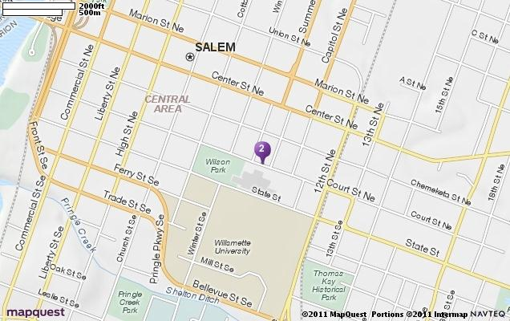
We would like to help you attend and bring youth to our 2017 Awareness Day Event. Reimbursements are on a first come, first serve basis, until our total budget for travel is expended. We ask that you carefully consider whether you need to be reimbursed for travel, as our budget is limited and there may be people who cannot participate without travel reimbursement.

Buses: | Cars:
The reimbursement rate for a bus varies depending on the distance you are traveling and the number of advocates you are bringing. We encourage you to maximize the number of youth you transport. Consider sharing a bus with another school that may be on the same route to Salem. | The Alliance’s reimbursement policy for car travel to Awareness Day is $.575 per mile (this is based on the IRS mileage reimbursement rates driven in services of a charitable organization). In order to receive reimbursement, cars must travel with at least 2 Awareness Day participants.

Please fill out the form below and send it to megan@osbha.org.

Name:___________________________________ | Email:____________________________________
Phone:___________________________________ | County:___________________________________
How many people are you bringing to Awareness Day? _____ # students _____ # other advocates.

From what schools? ____________________________________________________________________

Are you traveling by BUS or CAR (Circle One) # miles round-trip (if traveling by car):________
Cost of mileage/bus rental: ________________

Scholarship Amount Requested: ____________ Scholarship Amount Granted: ______________

Payee (who should the check be made out to?) ______________________________________________

Payee Address:

If you would like to be reimbursed for your travel to Salem, you must submit this form to be considered for reimbursement. We will bring checks with us to the event and ask that you verify the number of people that you bring with you.

WE WILL HAVE THESE AVAILABLE TO DO AT AWARENESS DAY 2017

Month XX, Year

Senator / Assembly member
ADDRESS

Dear Senator/ Assembly member,

On behalf of the <<School-based Health Program>> we would like to thank your office for meeting with us on February 27th, 2017 to discuss the future of School-Based Health Centers (SBHCs). It was a great pleasure to meet with your staff, and we want to express our personal thanks for the continued support we receive from you and your staff.

As you know, the SBHC health care model effectively delivers comprehensive physical and mental health services to children and adolescents directly on school grounds. This location is instrumental in the early detection of physical, behavioral, and emotional health issues. SBHCs are in a position
within the schools to properly address health issues affecting the local communities, such as asthma,
smoking and obesity, through asthma monitoring, smoking cessation programs, and nutritional initiatives. In addition, SBHCs benefits the community by preventing unnecessary hospitalization of students, reducing emergency room visits, improving school attendance, and helping parents avoid lost workdays.

We would like to thank your office again for taking the time to meet with us about the importance of School-Based Health Centers. We appreciated the opportunity you provided to share stories about our experiences with our School-Based Health Centers.

We would like to invite you and your staff to visit the SBHCs in your district to see for yourselves the positive impact they are having on the student’s lives. We look forward to hearing from you about a visit and about your support for these vital comprehensive health services.

Sincerely,

APPENDIX H: Story Form
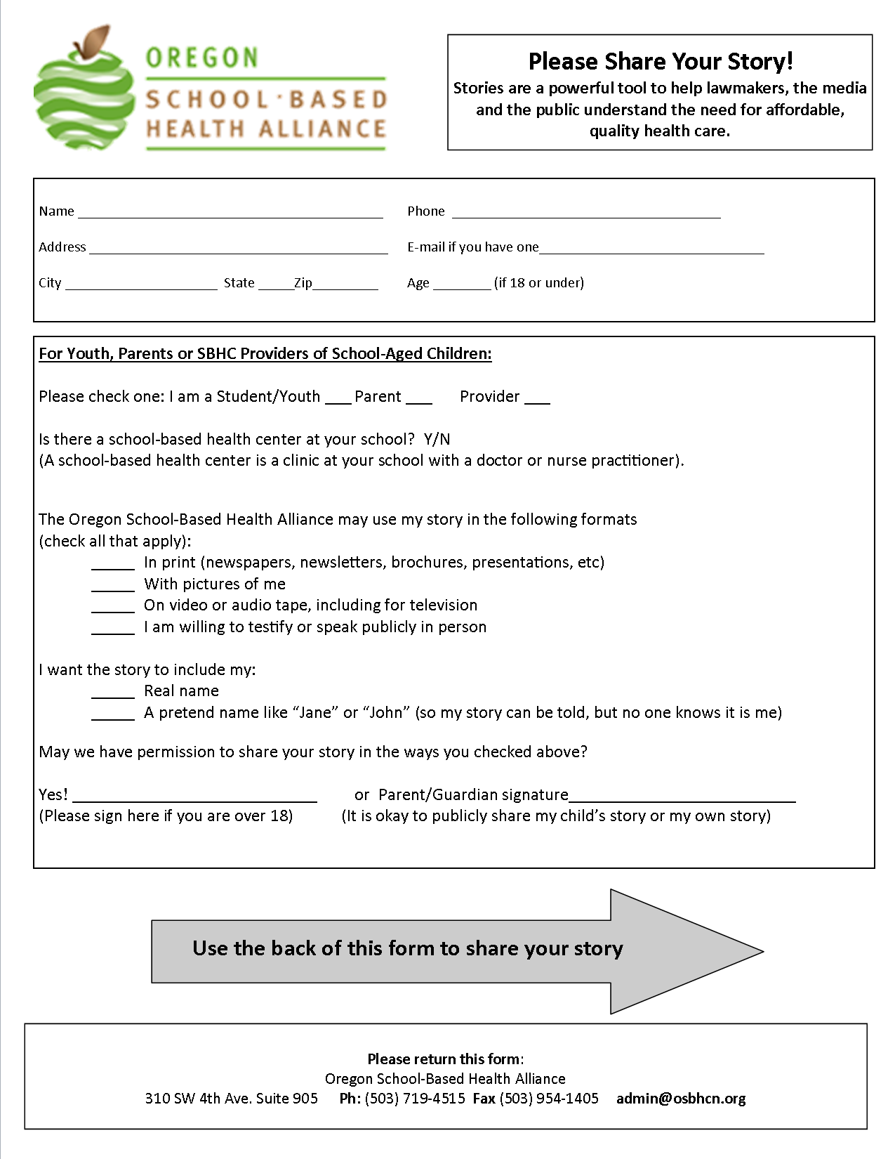

Your Story Form – Page Two
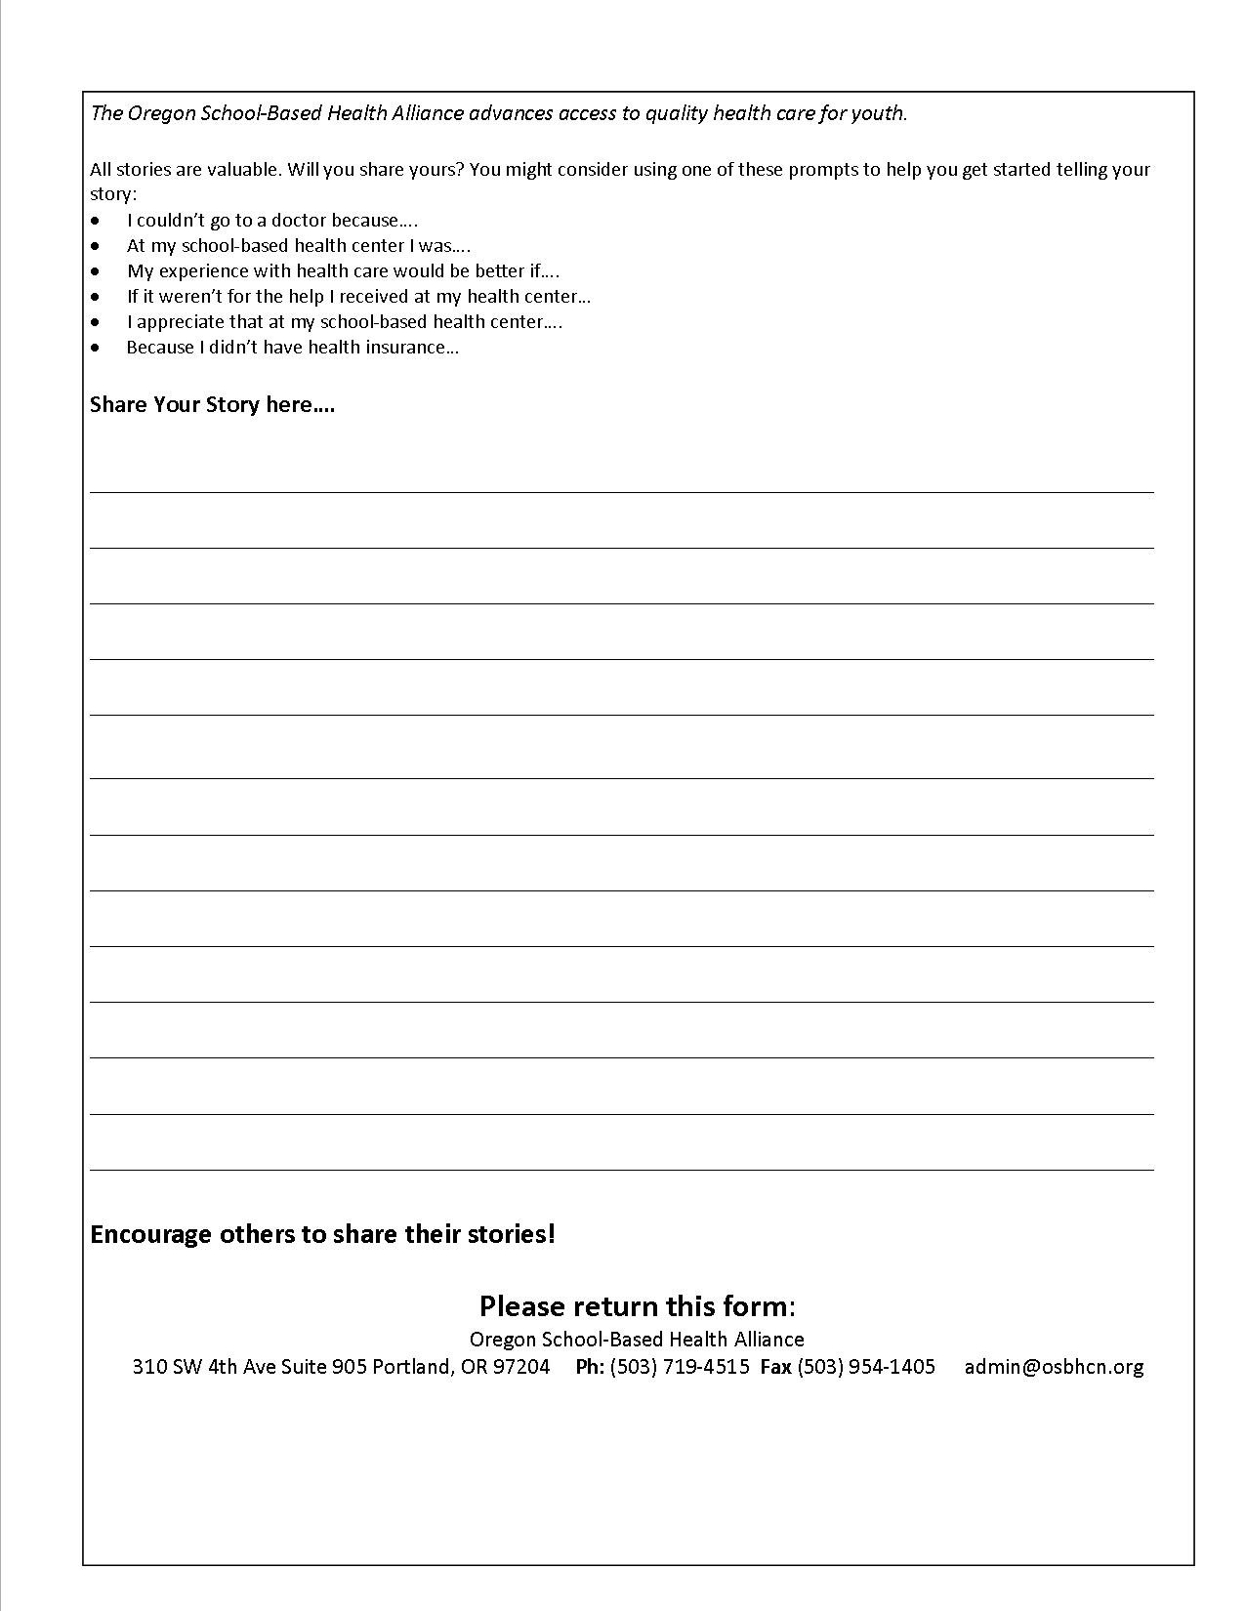

APPENDIX I: Checklist

- Generate the interest: Speak with your school principal (or if applicable the superintendent) to invite the school to participate. Once the principal approves, develop student permission forms that can be distributed by the teachers.

  - Set a deadline for interested attendees

  - Identify budget and funding

  - Know the school procedure for trips

  - Recruit Adult Chaperones & Advocates

  - Register your group by February 15th, 2017

  - Arrange for Bus or carpool transportation

  - Schedule legislative meetings – See Awareness Day Schedule for preferred times

  - Collect Consent Forms and Photo Releases, make duplicate copies and bring all to the event. Pass one set to OSBHA.

  - Have participants complete their story forms, make duplicate copies and bring all to the event. Pass one set to OSBHA

  - Create your table top display

  - Collect and Distribute Emergency Numbers (send to OSBHA)

  - Plan for Lunch/Snacks

  - Outreach to the Media – schedule radio interviews, send press releases to local print news, TV and radio stations

  - Coordinate the Bus Pick up/ Drop off locations

  - Have a copy of the driving directions to Salem

  - Conduct Legislative Meeting

  - Participate in event debrief prior to departure - Complete evaluation forms.

  - Write thank you letters to legislators within 5 business days – have all participants sign them (WE WILL HAVE THESE AVAILABLE TO DO AT AWARENESS DAY 2017)

  - Follow up Awareness Day with local activities/event

