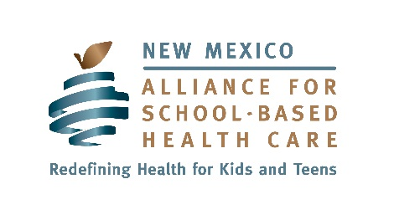

New Mexico Alliance for School-Based Health Care

Strategic Plan

VISION

The New Mexico Alliance for School-Based Health Care (NMASBHC) envisions healthy students who are ready to learn.

MISSION

The New Mexico Alliance for School-Based Health Care represents school-based health centers (SBHCs) in New Mexico and collaborates with other partners to promote, facilitate and advocate for comprehensive, culturally competent health care, including health education, in schools.

CORE VALUES

We believe in universal access to affordable, high quality health care provided in schools and communities because good health is essential for student success, and health care, like public education, should be a right.

We believe in advocating for the health of children and youth and for the provision of high quality, accessible, confidential, comprehensive, culturally competent health care in schools.

We believe in celebrating diversity in the community of students, parents, providers, and schools.

We believe that SBHCs, as a valuable component of the healthcare delivery system, should be appropriately funded and reimbursed.
Aim: Public and political support for school-based health care is built and maintained. |  |  | Measure: National, state, local and tribal policies support school-based health care.
Strategies | Activities | Timelines (Dates) | Responsible Entities | Indicators
Advocate for school-based health care, services and education at the state, national, tribal and local levels.
Build relationships with stakeholders and policymakers to advance the goal of sustainable support and funding for school-based health care in New Mexico.

Aim: SBHCs have the capacity to meet the needs of their communities. |  |  | Measure: SBHCs improve the health and educational outcomes of students in their communities.
Strategies | Activities | Timelines (Dates) | Responsible Entities | Indicators
Build and develop relationships between stakeholders to support SBHCs and School Health Advisory Councils (SHACs).
Provide resources to support SBHCs and SHACs.

Provide consultation, support, technical assistance and training to SBHCs and SHACs.

Aim: NMASBHC is an optimally functioning organization. |  |  | Measure: NMASBHC Board, employees and members achieve the vision of the organization.
Strategies | Activities | Timelines (Dates) | Responsible Entities | Indicators
Ensure the organization is governed and supported by the Board of Directors.
Ensure sufficient financial resources to support organization operations.

Operate the organization according to best practices for a comparable non-profit.

