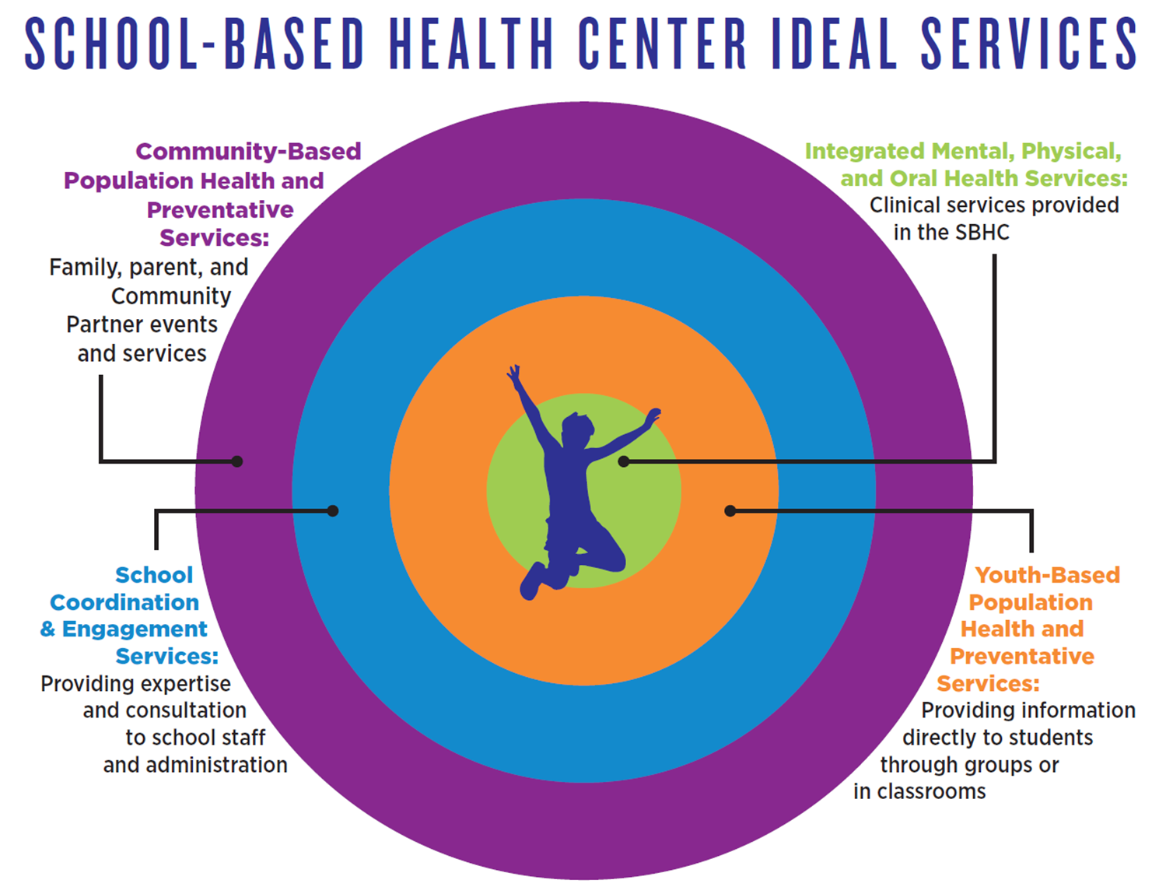
SBHC Ideal Services Defined - SBHCs are a cost-effective model offering accessible health services to children and adolescents in school. They address health disparities and social determinants of health, promote health literacy, and improve academic outcomes by keeping students in the classroom and ready learn.

- Population Health & Preventative Services- Community-Based:
  - Attend family-oriented school events: B2SN, multi-cultural night, resource fairs
  - Coordinate outside resources
  - Facilitate/Support Parent Groups (budgeting, healthy eating, navigating social services)
- School Coordination and Engagement Services:
  - Attend school staff and committee mtgs (PBIS, SIT, Safety, etc.)
  - Coordinate with school staff regarding high risk students
  - Work with school administration to develop policies and procedures regarding health and wellness
  - Provide crisis response and support
  - Provide subject matter expertise on health topics and student population
- Youth-Based Population Health and Preventative Services
  - Student groups (anger management, nutrition, coping with stress/anxiety)
  - Health education in classrooms
- Integrated mental, physical and oral healthcare services:

Well-child exams
Immunizations
Preventive and primary dental care
Mental health counseling
Behavioral health counseling
Family planning
Chronic disease management
Screenings (depression, substance abuse)
Health education
Panel management outreach and coordination

